Quant Research Meeting
Mar 20th, 2015 | Location: Conference Room
Agenda

- Project Status
  - Completed Projects
    - Deployed Yield Curve Daily Build process at 5:30 pm daily Mon-Fri (Johnson)
    - Code reviewed Current Coupon code base with Lien (Johnson)
    - Productionalize 30-year FNMA and GNMA current coupon (Lien)
      - Upload historical data back to 2009
      - Set up daily process to calculate the rates
    - Daily Bank Mortgage Rate report (Lien)
      - Add a historical chart for "servicing spread vs current coupon"
    - Research on Origination Market Concentration (Lien)
      - Build a query to get top 5 originators every month
      - Analyse the behaviour of ticker with name N/A and Remain
      - Track the market share changes for top 10/5/1 originators
      - Compare 1-month lag between issue date and asof with no lag data
      - Build a combined strategy separated
      - Build VBA code to automation the report
    - Swaption Volatility report (Lien)
      - Calculate historical volatility for current coupon return/log return
    - Primary Market Daily Report(Lien)
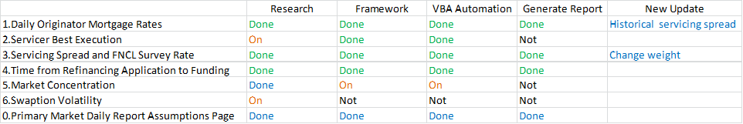
    - Accordion - R project for STACR/CAS model specification/estimation (Bobby)
      - Historical Metrics + bucketing, projection setup module
    - Credit Loan Data Prepayment/Transition Report (Raj)
      - Design/test query for Freddie/Fannie Data dynamic data (done)
      - Finalize list of fields to be incorporated in new dynamic table (done)
      - Generate Prepayment/Transition Reports (in progress)

  - In Progress
    - Roll out Daily Yield Curve process (Johnson)
    - Rewriting script for scrubbing Credit loan data (Raj)
    - Prepayment/Roll-rate reports (Raj)
    - Research on Origination Market Concentration (Lien)
      - Build VBA code to automation the report
    - Swaption Volatility report (Lien)
      - Compare real vol with swaption vol
    - Accordion - R project for STACR/CAS model specification/estimation (Bobby)
      - Past/Future prediction module (roll rates matrices)
    - Implement unit test program leveraging Google Test/boost unit test (Neo)
    - Implement new yield curve builder leveraging QuantLib library and compare the results (Neo)
Attendees

Derek Ho, Sharad Chaudhary, Neo Wang, Lien Chen, Robert Morris, Raj Savai, Johnson Hogwarts

